**Interaction** **modes (&Design Principles) in VR Applications**

**Abstract**

Nowadays the computer seems becoming more and more intelligent, people even can talk with a robot, and has a logical conversation, it is relatively naturally just like that with human. There are more and more intelligent ways for the interaction between human and machines, such as by **eyeball-tracking, gesture recognition, motion capture, tactile feedback, speech recognition, sensor induction**, **Electrical Muscle Stimulation, A real space. etc**. In this paper we introduce each of the interaction modes in VR applications. Each of these patterns presents advantages and disadvantages, by analyzing these characteristic, find the most natural way to interactive, draw a conclusion that each modes’ suited application types.

**Introduction**

Each of the notable landmarks in the progress of interaction designs development is the Collision of modern science technology and humanity. For communicating with the computer, from the very beginning, Users prepared their programs by punching them (in assembler) onto a paper tape, to the mostly common used devices- keyboard and mouse, then, appeared the touch operation mode, Speech Recognition Model, eyeball-tracking, gesture recognition, motion capture, tactile feedback, speech recognition, sensor induction, Electrical Muscle Stimulation, A real space, etc. How these interaction modes work in VR?

1. **Interaction Modes (Patterns)**
   * **Speech recognition**

The easiest way to transmit the conversation between human and VR world, users immediately get the information from the earphones. Most HMD devices have earphones. But the problem is when VR devices get the users’ voice, it is harder to be understood than just give a speech to user. Like the smart phone Siri system, users need a logical feedback that they expectant.

* + **Eyeball-tracking**

Eye tracking is among the most important features yet to be added to the technology stacks of the major virtual reality headsets. In fact it is something that is so important that in a recent interview with UploadVR Oculus’ founder, Palmer Luckey, went as far as to call eye tracking a “critical part,” of the future of VR technology [1]. Because of better eyeball tracking can provide a better and more natural 3D effect in current view angle, and lower the delay, so it can solve the HMD vertigo problem. E.g. Avegant Glyph

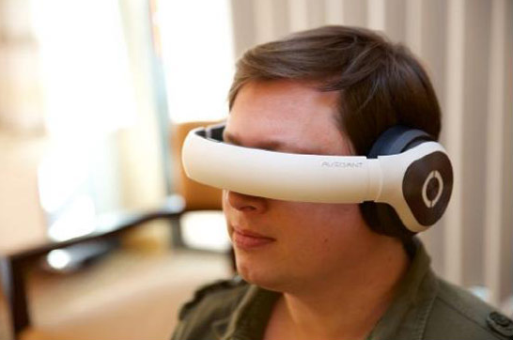

Fig. Avegant Glyph device

* + **Tactile feedback**

The standard interactive mode that most commonly used in the VR applications, such as press buttons on the controller or just vibration, Oculus , Sony and HTC Vive all have controllers match with their HMDs.

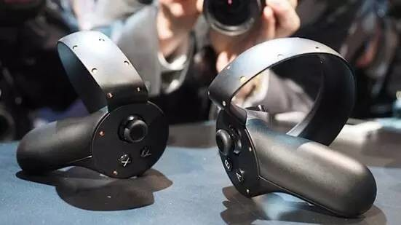

Fig. VR game controllers(one for one hand)

* + **Motion capture**

But it’s difficult for the user to know whether the action is resultful as the action has no feedback. Perception Neuron; Kinect

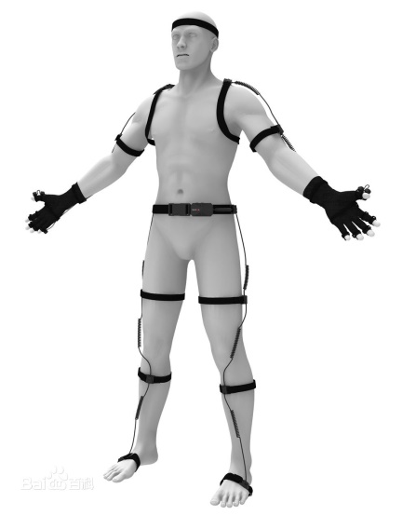

Fig. Perception Neuron action tracking device

* + **Gesture Recognition**

According to the working mechanisms, gesture recognition can be divided into two parts: optical tracking such as LeapMotion, NimbleVR, Hololens which use [depth](javascript:void(0);) [transducer](javascript:void(0);) and Data gloves.

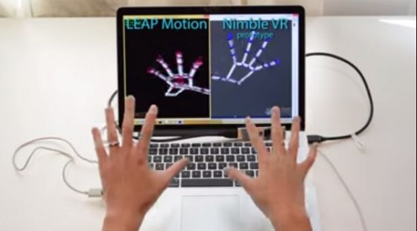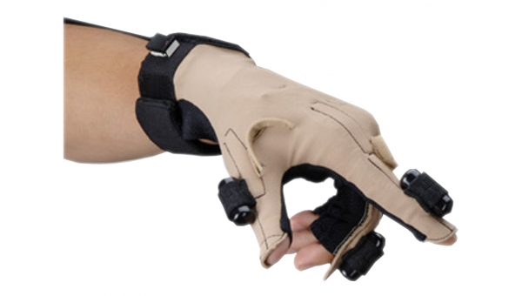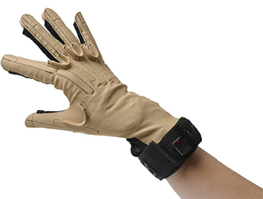

Fig. two different gesture recognition ways: leapmotion NimbleVR [4](up) and Data gloves(down)[5]

* + **Electrical Muscle Stimulation**

‘Impacto’ [2]is a VR boxing device that developed by HCI（Human-Computer Interaction）in Germany. It Combined haptic feedback and Electrical Muscle Stimulation to simulate the real feel when boxing.

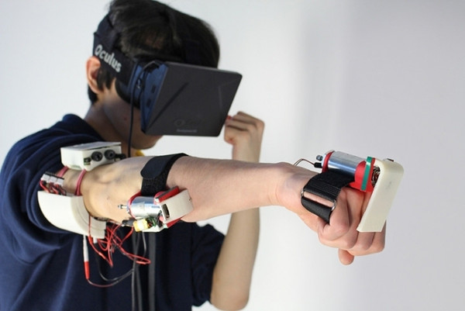

Fig. Impacto VR device

* + **Build A real VR space**

Make a virtual world that just like the real world but use the VR devices to interact. “This technology allows us to create the illusion that the player is exploring miles of terrain or incredibly tall structures without ever leaving our game pod. The end result is a physical connection to the virtual world and a sense of exploration never before possible.”  By The VOID[6].

 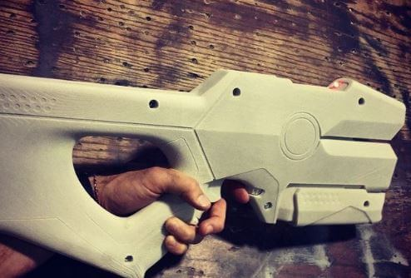 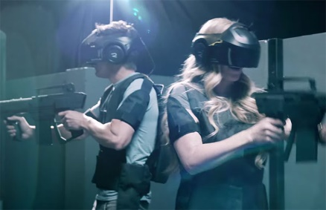

Fig. (left) The wall in each The VOID’s room are removable and module Image: Washington Post, (middle) The VOID’s own Rapture Gun[6], (right)players in the VOID.

1. **Interaction modes’ advantage and disadvantages**

how to choose an interaction mode in a VR application？Each of the modes has its advantages and disadvantages. …

1. **Design guidelines**

The best interaction way is what people use in real life, people get the skill through daily experiences, so that when similar situation appeared in the virtual reality, they needn’t to study or train the operations ways. There are some guidelines[7]:

* + Human- centered design

Focus on the user experience

…

1. **Summary**

We have listed the present interaction ways in VR applications and …

**References**

[1] ”Oculus is working on eye tracking technology for the next generation of VR”by [WILL MASON](http://uploadvr.com/author/will/) 2015.10.8th.

[2] “VR boxing device ‘Impacto’ - Using Electrical Muscle Stimulation”. <http://it.sohu.com/20151113/n426406770.shtml>

[3] “Human-Centered Design for VR Interactions”, J Jerald，R Marks, 2016

# [4] “Nimble VR vs LEAP Motion – Skeletal Tracking”,

# [5] “Feedback Devices”, <http://www.th-wildau.de/sbruntha/Material/VR/Websites-T11/FeedbackDevices/ForceFeedback.html>

# [6] “The VOID Theme Park: Future of Immersive Virtual Reality + Physical Reality Gaming Experience”

# [7]”The VR book - Human-Certered Design for Virtual Reality”, Jason Jerald, Ph.D.